Single-Port RAM
Functional Verification
Project Report
submitted by
Rohit Kiran Kumar Shettigar | Emp ID: 6925
Mirafra Software Technologies Pvt. Ltd
July 2026

Table of Contents
1. Project Introduction 3
2. Objectives 4
3. Design Specification 5
Block Diagram 5
Pin-Out Diagram / Pin Description 5
4. Memory Operation Timing 7
Write Operation Timing 7
Read Operation Timing 7
5. Testbench Architecture 9
Testbench Block Diagram 9
Component Descriptions 9
6. Quality Assessment — Code Coverage 10
7. Results 12
Simulation Results 12
Resolved Issue — Reset / Memory Initialization Mismatch 12
8. Conclusion 14
9. Future Work 15
Appendix A — Source Code Repository 16

1. Project Introduction

What is this project
This project presents the functional verification of a single-port Random Access Memory (RAM), implemented in synthesizable Verilog HDL and verified with a SystemVerilog class-based testbench. The design is developed as part of the Mirafra Technologies training program, following industry-standard RTL design and verification practices.

What is a single-port RAM
A single-port RAM is a memory block that exposes a single address/data interface shared between read and write operations. Because only one port is available, the design does not support simultaneous read and write access to the memory in the same cycle — each cycle can perform at most one operation.

Design summary
The RAM operates at 50 MHz, is 8 bits wide and 32 locations deep, and is controlled by separate write_enb and read_enb signals along with a 5-bit address bus. Reset is used to bring the design to a known idle state before normal operation begins.

Verification approach
The RAM is verified using a SystemVerilog class-based testbench following the classic generator-driver-monitor-scoreboard architecture, with an independent behavioural reference model used as the golden model for functional comparison. The testbench automatically compares DUV outputs against the reference model for every genuine read operation and reports MATCH or MISMATCH counts, along with functional and code coverage of the input and output spaces.

2. Objectives
- Study and understand the single-port RAM architecture and pin-level description as specified in the RAM Design Specification document.
- Implement a synthesizable RTL design in Verilog HDL covering write and read operations with correct handling of clock and reset.
- Design and implement a behavioural reference model (ram_reference_model) that serves as the golden model for functional comparison during verification.
- Develop a structured, class-based SystemVerilog testbench (transaction, generator, driver, monitor, reference model, scoreboard, environment) that automatically drives inputs, compares outputs, and reports results.
- Verify write operation, read operation, read-after-write correctness, reset behaviour, idle (no operation) behaviour, and the no-simultaneous-read-write constraint.
- Achieve maximum functional and code coverage including statement, branch, toggle, and functional (covergroup) coverage through comprehensive test case selection.

3. Design Specification
This is a single-port RAM. The operating frequency for the RAM is 50 MHz. The RAM is 8 bits wide and 32 locations deep. When reset is asserted, the RAM is in idle state — all inputs become zero except data input, which becomes high-impedance (Z), and the data output also becomes Z. The RAM supports both read and write operations, and it does not support concurrent read and write operations.

Block Diagram
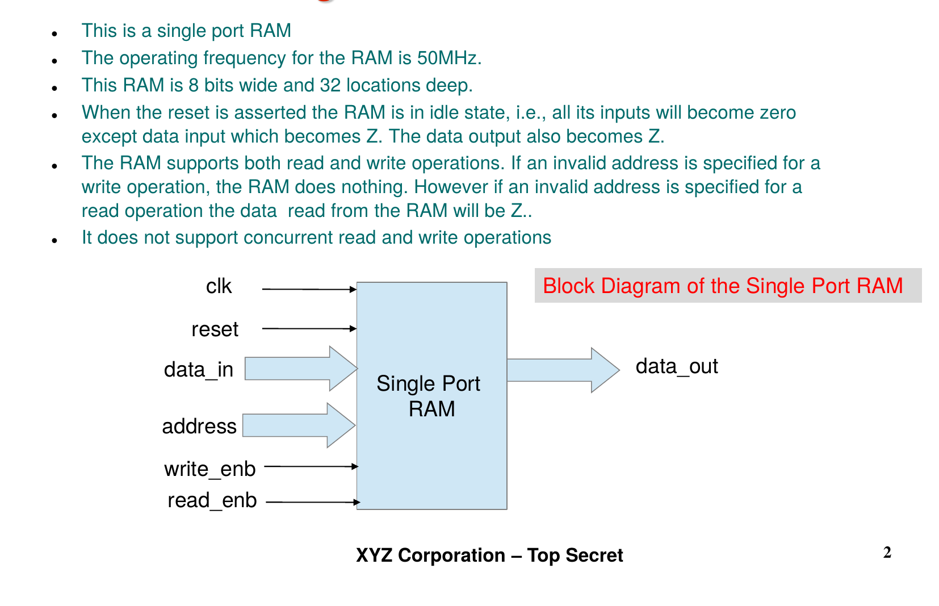
Figure 1: Block Diagram of the Single-Port RAM (from the Design Specification)

Pin-Out Diagram and Pin Description
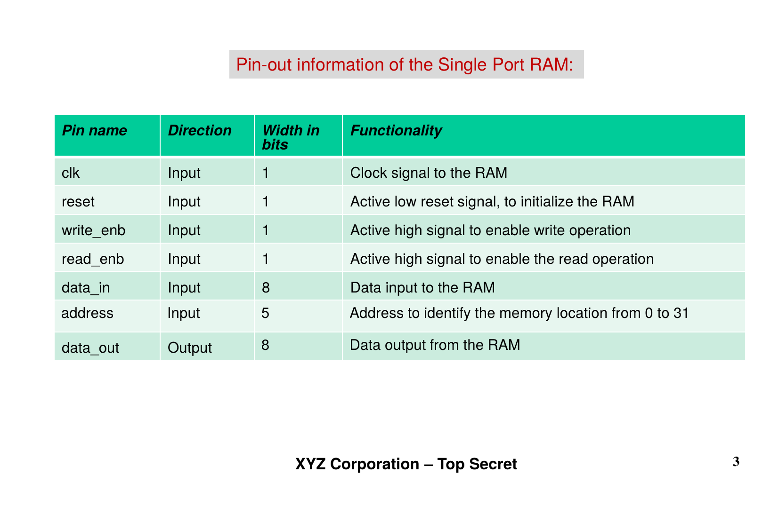
Figure 2: Pin-Out Information of the Single-Port RAM (from the Design Specification)

4. Memory Operation Timing

Write Operation Timing
When reset is asserted, data_in is high-impedance and address is zero. When reset is released, write_enb=1 and read_enb=0, the data_in value is written into the corresponding memory address on the next positive clock edge.
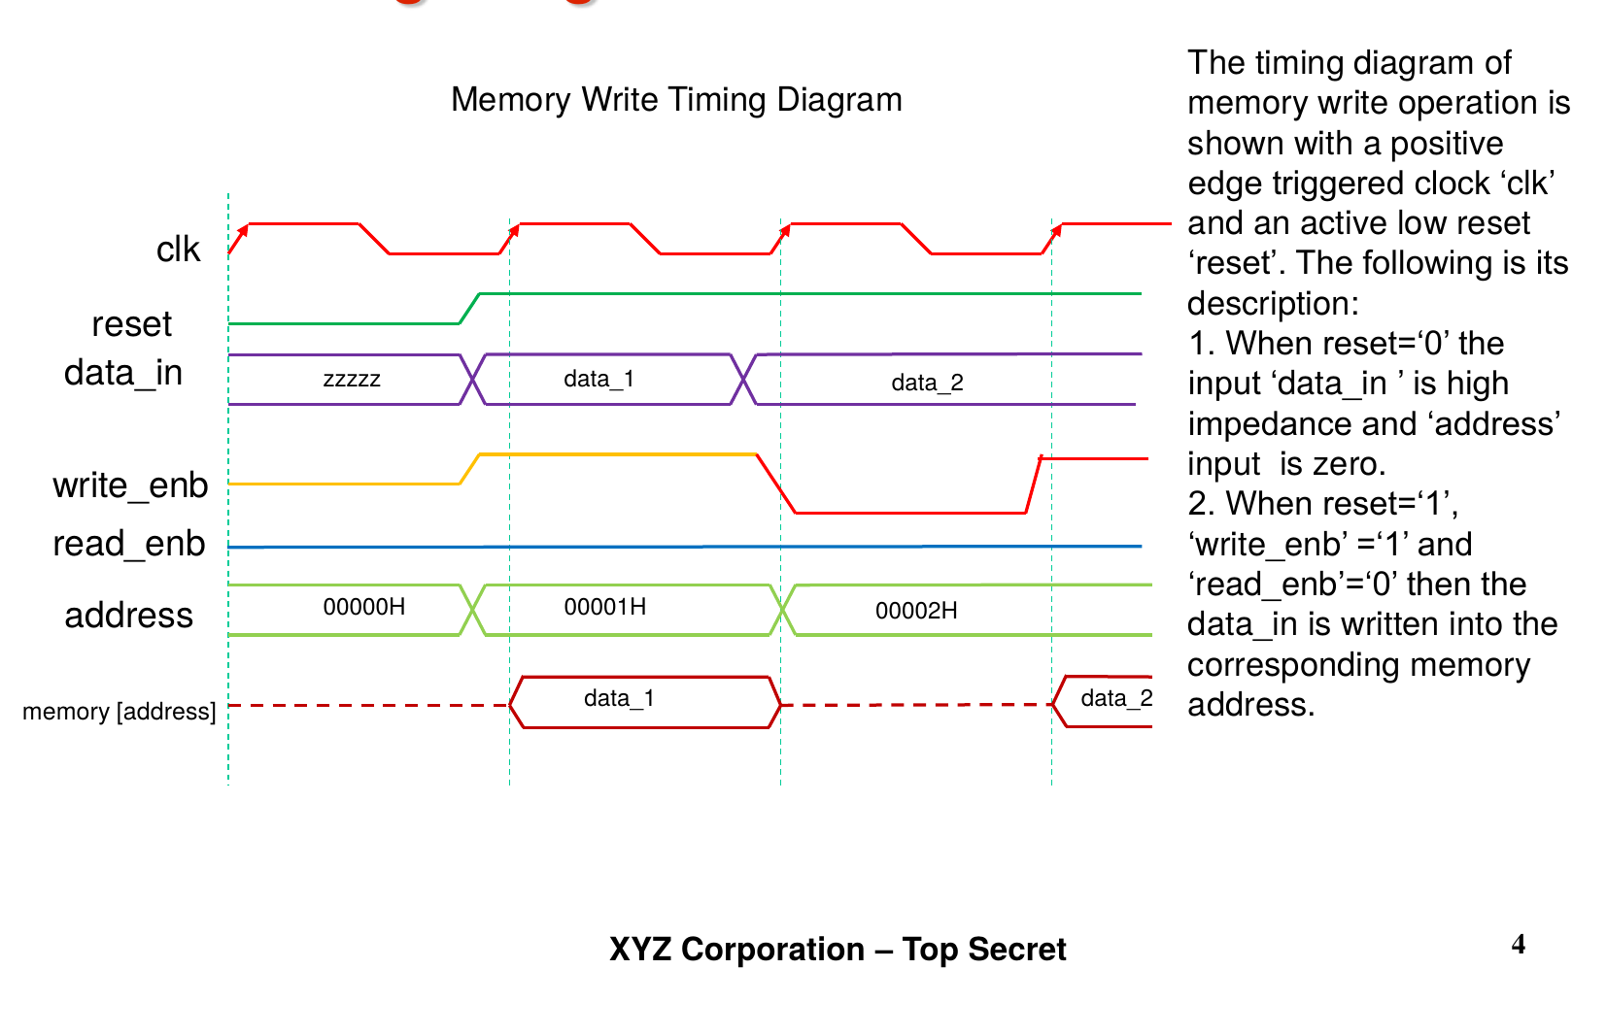
Figure 3: Memory Write Timing Diagram (from the Design Specification)

Read Operation Timing
When reset is asserted, data_out is high-impedance and address is zero. When reset is released, write_enb=0 and read_enb=1, the data_out reflects the contents of the corresponding memory address.
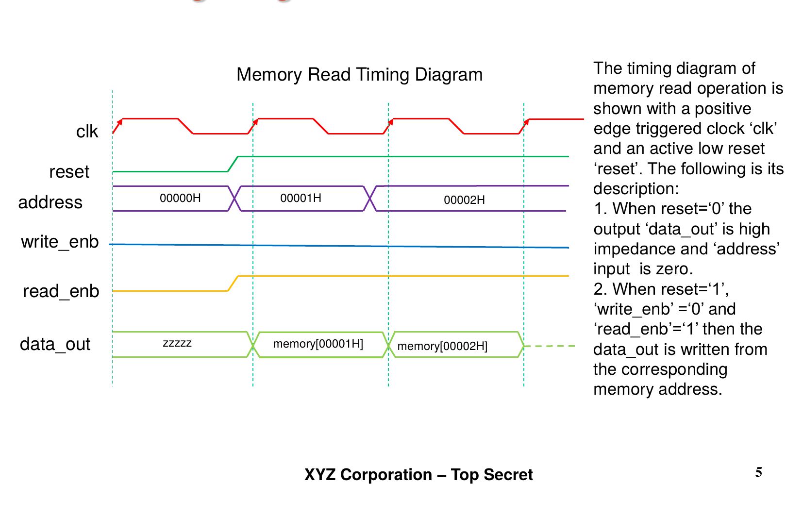
Figure 4: Memory Read Timing Diagram (from the Design Specification)

5. Testbench Architecture

Testbench Block Diagram
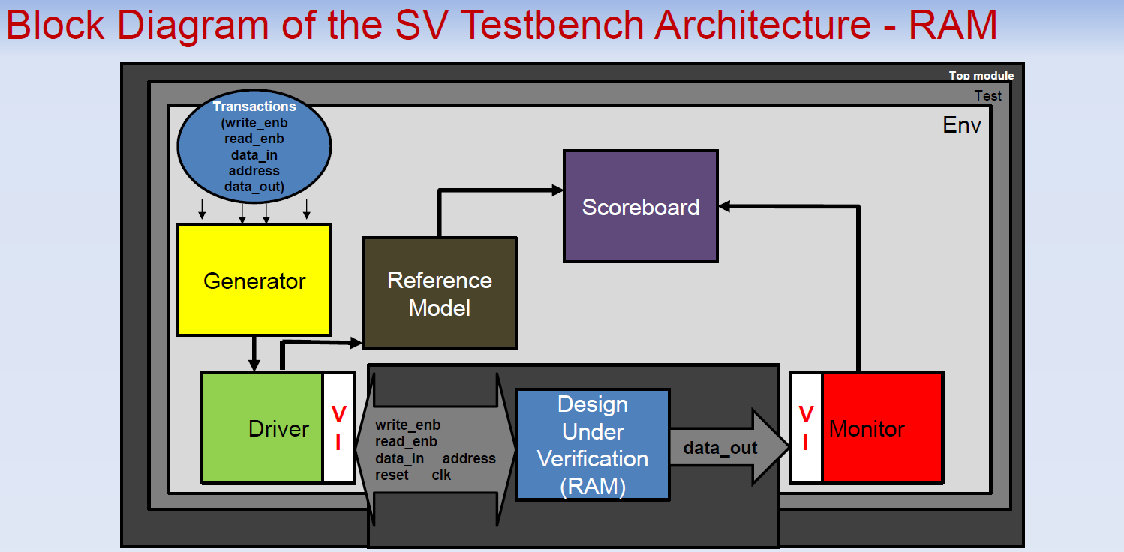
Figure 5: Block Diagram of the SV Testbench Architecture — RAM

Overall Structure
The testbench is a class-based SystemVerilog environment consisting of a generator, driver, monitor, reference model, and scoreboard, connected through mailboxes and coordinated by an environment class. A virtual interface connects the testbench to the DUV, guaranteeing race-free signal timing between drive and sample points.

Component Descriptions
- ram_trans — the stimulus data packet, carrying randomized write_enb, read_enb, data_in, address, and an explicit reset field, constrained to valid combinations.
- ram_generator — randomizes transactions, including the reset scenario, and forwards them to the driver via a mailbox.
- ram_driver — drives randomized transactions onto the DUV's input pins, routes the reset branch to the DUV, and forwards the same transaction to the reference model.
- ram_monitor — passively observes the DUV's data_out and address and forwards captured results to the scoreboard.
- ram_reference_model — an independent, behavioural golden model of the RAM's expected behaviour, used to compute the expected data_out for every read, including the reset case.
- ram_scoreboard — compares the reference model's expected result against the monitor's observed result for every genuine read operation and for the reset case, and reports MATCH/MISMATCH counts.
- ram_environment — constructs and wires together all components and runs them concurrently.
- ram_test — test class that drives the generator and runs the full environment.

6. Quality Assessment — Code Coverage
The testbench was simulated with code and functional coverage enabled in QuestaSim, across the full design hierarchy (interface, DUV, and every testbench class).

Overall Coverage Summary
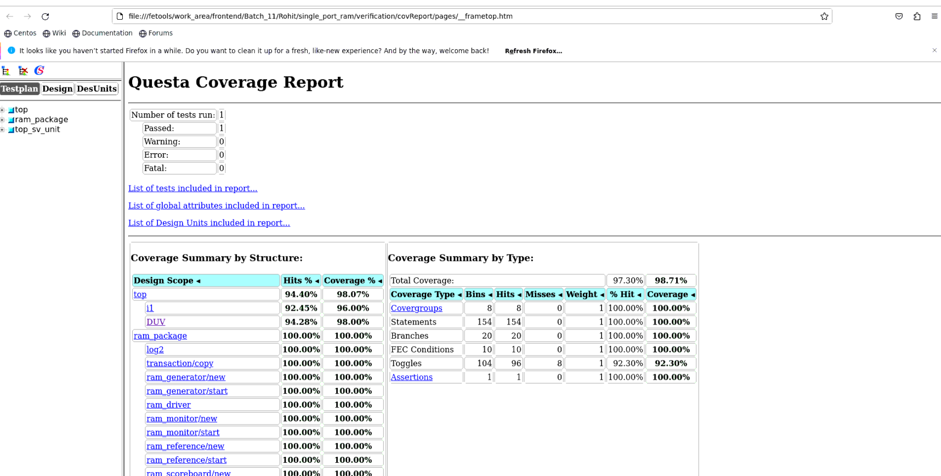
Figure 6: Questa Coverage Report — RAM Project (Rohit Kiran Kumar Shettigar)

Coverage Summary by Type
Coverage Type | Bins | Hits | Misses | Weight | % Hit | Coverage
Covergroups | 8 | 8 | 0 | 1 | 100.00% | 100.00%
Statements | 154 | 154 | 0 | 1 | 100.00% | 100.00%
Branches | 20 | 20 | 0 | 1 | 100.00% | 100.00%
FEC Conditions | 10 | 10 | 0 | 1 | 100.00% | 100.00%
Toggles | 104 | 96 | 8 | 1 | 92.30% | 92.30%
Assertions | 1 | 1 | 0 | 1 | 100.00% | 100.00%
Total Coverage |  |  |  |  | 97.30% | 98.71%

Key Observations
- Total coverage: 97.30% (Hits) / 98.71% (Coverage %) at the top level — a significant improvement over the previous run.
- Design-scope breakdown: top 94.40% / 98.07%, i1 92.45% / 96.00%, DUV 94.28% / 98.00%, ram_package 100.00% / 100.00%.
- Statement coverage reached 100% (154 of 154 bins hit).
- Branch coverage reached 100% (20 of 20 bins hit).
- FEC Conditions reached 100% (10 of 10 bins hit).
- Functional covergroups reached 100% (8 of 8 bins hit), and every testbench class reported full coverage.
- Toggle coverage reached 92.30% (96 of 104 bins) — the only remaining gap, consistent with a small number of signal transitions not yet exercised by the current stimulus set.
- Assertions reached 100% (1 of 1) — the RESET DATA_OUT check passed.

7. Results

Simulation Results
The self-checking testbench was simulated using QuestaSim. This run generated 40 transactions, all driven through the scoreboard for reference-model vs. DUV comparison.
Metric | Value
Total Transactions Generated | 40
Genuine Reads / Checks Compared | 40
MATCH | 40
MISMATCH | 0
Pass Rate (of compared reads) | 100.00%

Test Plan and Execution Status
The verification plan below lists the feature-level test cases executed against the design, along with pass/fail status observed in this run.
ID | Test Name | Expected Output | Status | Remarks
1 | Clock Toggling | Clock is toggling correctly | PASS | —
2 | Synchronous Reset | On reset, data_out = Z, all memory initialized to 0 | PASS | Bug fixed — see below
3 | Write to Valid Address | Data is written into the correct address | PASS | —
4 | Write to Invalid Address | Memory contents must remain unaffected | PASS | —
5 | Read from Valid Address | data_out should be correct | PASS | —
6 | Read from Invalid Address | Address is truncated; truncated address data is read | PASS | —
7 | Concurrent Read and Write | No simultaneous read/write allowed | PASS | —

Resolved Issue — Reset / Memory Initialization Mismatch
STATUS: FIXED
Original bug: when an address that was never explicitly written was read following reset, the DUV and the reference model reported different unknown-value signatures (reference model 'z' vs. monitor 'x'), causing 12 of 27 compared reads to mismatch.
Fix applied: the design's reset branch was updated to loop over all 32 memory locations (foreach (memory[i]) memory[i] = 0;) and clear each to a known 0 value on reset, instead of leaving them undriven.
Result: re-running the regression after the fix produced 40 MATCH / 0 MISMATCH — a 100% pass rate on all compared reads, confirming the reference model and DUV now agree on post-reset memory state.

8. Conclusion
This project implemented a single-port RAM in synthesizable Verilog HDL, and verified it using a class-based SystemVerilog testbench following the generator-driver-monitor-scoreboard architecture with an independent behavioural reference model, extended with an explicit reset field routed through the scoreboard.
The testbench correctly verified write operations, write-to-invalid-address handling, read operations, read-from-invalid-address (truncated address) handling, reset behaviour, and the RAM's rejection of simultaneous read/write requests, achieving 100% functional (covergroup) coverage and 98.71% overall coverage. The previously documented reset-initialization bug has been fixed and re-verified: the design's reset branch now clears all 32 memory locations to 0, and the latest regression reports 40 MATCH / 0 MISMATCH (100% pass rate) across all compared reads.

9. Future Work
- Add a deliberate negative test (inject a known RTL bug, confirm the scoreboard reports MISMATCH, then revert) to prove the scoreboard is capable of detecting real functional faults.
- Add a mid-simulation reset pulse to exercise the driver's reset-handling branch while active, to close the remaining toggle coverage gap (currently 92.30%).
- Extend functional coverage to explicitly track read-after-write address correlation as a cross-coverage bin.
- Add assertion-based verification (SVA) for additional protocol-level checks such as write-then-read ordering and reset-to-idle timing.
- Increase the regression transaction count and add directed corner-case scenarios (all-address sweep, back-to-back writes) to push toggle coverage toward 100%.

Appendix A — Source Code Repository
The complete RTL design, SystemVerilog testbench source, simulation log, and Questa coverage database for this project are hosted on GitHub at the link below.
https://github.com/rohitshettigar103/single_port_ram

Repository Contents
File | Description
design.v | Synthesizable Verilog RTL of the single-port RAM (DUV).
interface.sv | Virtual interface connecting the testbench to the DUV.
transaction.sv | ram_trans stimulus packet — randomized fields with constraints.
generator.sv | ram_generator — randomizes and forwards transactions.
driver.sv | ram_driver — drives transactions onto the DUV and the reference model.
reference.sv | ram_reference_model — golden behavioural model.
monitor.sv | ram_monitor — passively samples DUV outputs.
scoreboard.sv | ram_scoreboard — compares reference vs. monitor, reports MATCH/MISMATCH.
environment.sv | ram_environment — builds and runs all components concurrently.
test.sv | ram_test — top-level test class.
top.sv | Top-level module — clock/reset generation and DUV instantiation.
package.sv / ram_package.sv | SystemVerilog package bundling all testbench classes.
log_file.log | QuestaSim simulation transcript for this regression run.
ucdb_file.ucdb | Coverage database used to generate the Questa Coverage Report.

A.1 DUV Source — design.v (post-fix, reset now clears all memory)
module RAM(
clk, // Clk input
reset, //Reset input active low
address, // Address Input
data_in, // Data in
write_enb, // Write Enable
read_enb, // Read Enable
data_out // Data out
);
//Input port declaration
input [4:0] address;
input write_enb;
input read_enb;
input [7:0] data_in;
input clk;
input reset;
//Output port declaration
output [7:0] data_out;
//Variable declarations
reg [7:0] data_out ;
reg [7:0] memory [0:31];
initial begin
foreach(memory[i])memory[i]=0;
end
//Memory Write Block Write Operation : When write_enb = 1,
always @(posedge clk)
begin
if(!reset)
//Bug fixed
foreach(memory[i])begin
memory[i]=0;
end
else if(write_enb && !read_enb)
memory[address] <= data_in;
end
//Memory Read Block Read Operation : When read_enb=1
always @(posedge clk)
begin
if(!reset)
data_out <= 8'bz;
else if(read_enb && !write_enb)
data_out <= memory[address];
else
data_out <= 8'bz;
end
endmodule
Listing 1: Synthesizable RTL for the single-port RAM, cloned from https://github.com/rohitshettigar103/single_port_ram

A.2 Simulation Log Excerpt — log_file.log
Below is a condensed excerpt of the QuestaSim transcript for this run, showing the tool banner, a representative transaction/scoreboard check, and the final summary confirming 40 MATCH / 0 MISMATCH with 0 errors.
# vsim -vopt work.top -voptargs="+acc=npr" -assertdebug -l log_file.log -coverage -c \
# -do "coverage save -onexit -assert -directive -cvg -codeAll ucdb_file.ucdb; run -all; exit"
# Start time: 19:38:34 on Jul 07,2026
# // Questa Sim Version 10.6c linux Jul 25 2017
# Loading work.ram_package(fast)
# Loading work.RAM(fast)
# ** Warning: (vsim-3839) interface.sv(6): Variable '/top/i1/data_out', driven via a
# port connection, is multiply driven. Instance: /top/i1 File: interface.sv
# run -all
# Generated values
# data_in: 33,w_en:1,r_en:0,addr:13
# ...
# Driving to interface
# data_in:3a,w_en:0,r_en:1,addr:1e
# moitor passing value
# data_out:00
# Reference: data out at addr:12,data_out:00
######### [MONITOR TO SCOREBOARD], w=0,r=1, time:710, data_out=0 | address=12 #########
######### [REFERENCE -SCOREBOARD], time:710, data_out=0 | address=12 #########
# PASS: [SCOREBOARD] 710 REF data_out=0 | MON_data_out=0
# [MATCH] count = 32
# ... (transactions 33 - 39 omitted for brevity, all PASS) ...
# Driving to interface
# data_in:0d,w_en:0,r_en:0,addr:1d
# moitor passing value
# data_out:zz
######### [MONITOR TO SCOREBOARD], w=0,r=0, time:870, data_out=z | address=1d #########
# PASS: [SCOREBOARD] 870 REF data_out=z | MON_data_out=z
# [MATCH] count = 40
# ** Note: $finish : top.sv(40)
# Time: 870 ns Iteration: 3 Instance: /top
# Saving coverage database on exit...
# End time: 19:38:35 on Jul 07,2026, Elapsed time: 0:00:01
# Errors: 0, Warnings: 1
Listing 2: Excerpt of the simulation transcript, full file available in the repository (log_file.log)

